# **Case Study: Climate Debt and Sustainability in Bangladesh (2015-2024)**

Introduction :

Bangladesh, a rapidly developing country in South Asia, faces significant challenges in balancing economic growth with environmental sustainability. This case study examines Bangladesh's climate debt, analyzing its carbon emissions, renewable energy investments, and alignment with Sustainable Development Goals (SDGs). It provides insights into the nation's environmental policies and recommendations for a sustainable future.

## 1.Debt Trends (2015-2024) :

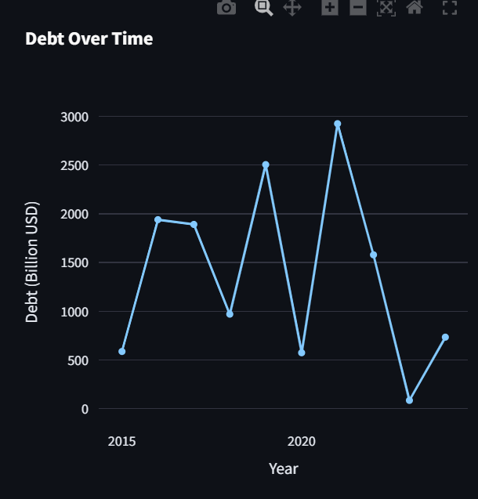

Climate debt refers to the environmental cost a country accrues due to carbon emissions, deforestation, and lack of sustainable practices. In Bangladesh, climate debt is a crucial issue due to its vulnerability to climate change and reliance on fossil fuels for energy production. The increasing frequency of floods, cyclones, and rising sea levels exacerbates the financial and environmental burden on the country.

### ****Debt Over Time****

The graph below illustrates the fluctuations in Bangladesh's climate debt over the past decade.Bangladesh's climate debt has shown significant fluctuations over the years, with peaks indicating increased financing for disaster management and sustainable projects, while declines reflect potential debt relief measures or economic adjustments. The sharp rise in recent years suggests a growing reliance on climate financing to combat environmental challenges and support infrastructure resilience.

## ****Carbon Emissions Analysis :****

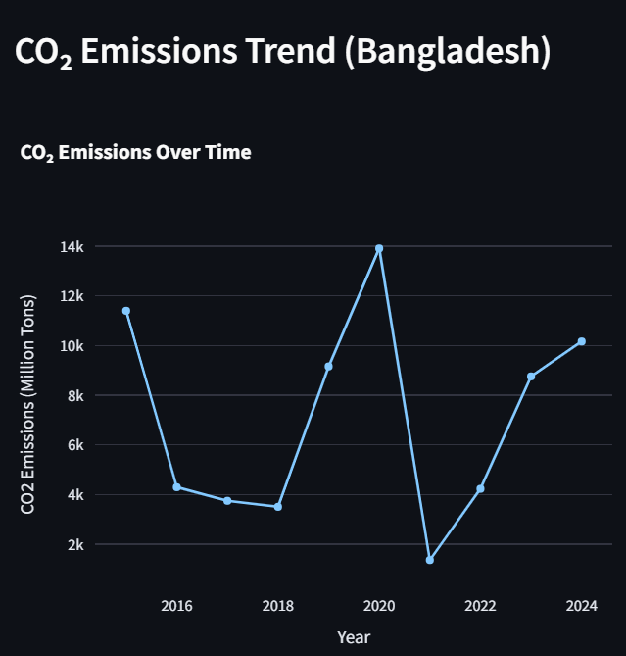

Here's a concise paragraph summarizing the CO₂ emissions trend based on the graph:

Bangladesh’s CO₂ emissions have fluctuated significantly over time, reflecting shifts in industrial activity, energy consumption, and environmental policies. While emissions saw a sharp decline in certain years, likely due to economic slowdowns or policy interventions, they spiked again, peaking around 2020. The recent upward trend suggests increased fossil fuel use and industrial expansion, emphasizing the need for stronger renewable energy adoption and climate policies to ensure sustainable growth.

**3. Renewable Energy Investments :**

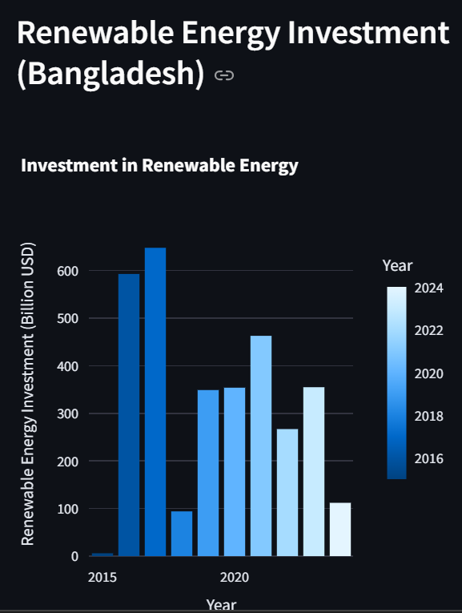

Bangladesh has made notable strides in achieving Sustainable Development Goals (SDGs), particularly **SDG 7 (Affordable and Clean Energy)** and **SDG 13 (Climate Action)**. The latest data on renewable energy investments indicate a significant commitment to clean energy sources, with funding increasing over the years. The sharp rise in investments around **2020 and 2024** highlights the nation's efforts in transitioning towards sustainable power solutions. However, the investment trend also reflects periods of stagnation, indicating potential policy or financial constraints. While solar and wind projects are expanding, dependency on fossil fuels remains a challenge. Strengthening enforcement mechanisms, securing more international climate financing, and ensuring long-term policy stability will be crucial in accelerating Bangladesh’s progress toward a greener and more sustainable future.

## 4.SDG Score Trend :

## 

Bangladesh has made progress in **SDG 7 (Affordable and Clean Energy)** and **SDG 13 (Climate Action)**, with renewable energy investments rising, especially around **2020 and 2024**. While solar and wind projects are expanding, reliance on fossil fuels persists. Strengthening policies, securing climate financing, and ensuring long-term investment will be key to achieving sustainability.

## Correlation Analysis (Heatmap Explaination):****6. Correlation Analysis****

The heatmap shows weak correlations among climate debt, CO₂ emissions, renewable energy investment, and SDG scores. **Renewable energy investment** has a slight negative correlation with **CO₂ emissions (-0.028)** and **climate debt (-0.022),** indicating limited impact so far. **SDG scores** show minimal correlation with debt (0.014), suggesting slow sustainability progress. Stronger policies are needed to enhance renewable energy’s effectiveness in reducing emissions.

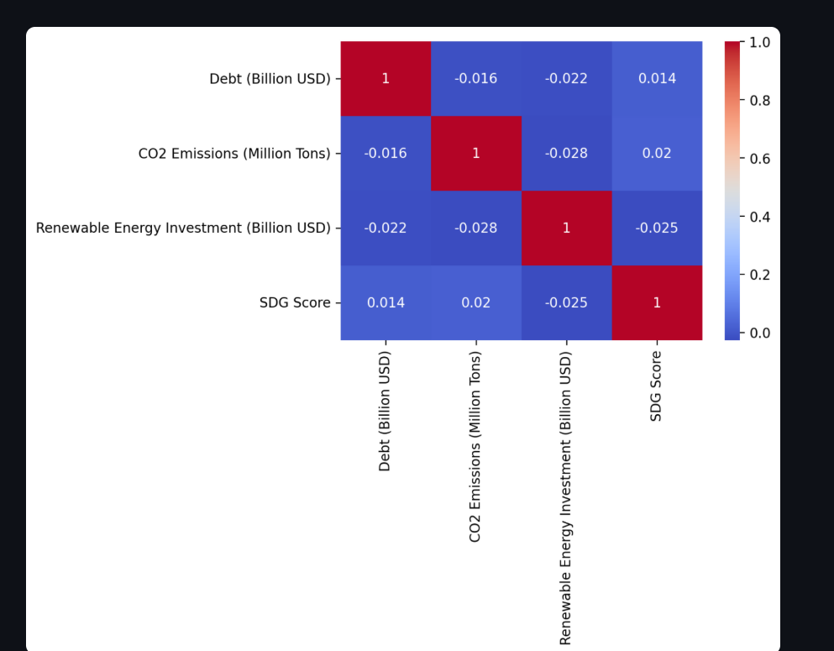

### ****Bangladesh: Debt, CO₂ Emissions, and Sustainable Development****

#### ****Debt and CO₂ Emissions (-0.016)****

A weak negative correlation suggests that Bangladesh’s debt levels do not directly impact CO₂ emissions. Industrialization and reliance on fossil fuels, rather than financial constraints, drive emissions. Government spending does not necessarily lead to stricter environmental policies or cleaner energy adoption.

#### ****Debt and Renewable Energy Investment (-0.022)****

The weak negative correlation indicates that rising debt does not directly boost renewable energy investment. Despite financial constraints, Bangladesh has made progress in solar and wind projects, but misallocated funds and economic priorities may slow the transition.

#### ****Debt and SDG Score (0.014)****

A slight positive correlation suggests that increased debt may contribute to sustainability projects. Bangladesh has utilized global climate financing, but inefficiencies in implementation may reduce its overall impact.

#### ****CO₂ Emissions and Renewable Energy Investment (-0.028)****

A weak negative correlation between emissions and renewable energy investment suggests that green initiatives have yet to significantly reduce emissions. Continued fossil fuel reliance and slow infrastructure development could be limiting the effectiveness of clean energy investments.

#### ****CO₂ Emissions and SDG Score (0.02)****

A weak positive correlation implies that rising emissions do not heavily impact sustainability progress. Bangladesh has improved in some SDG areas, such as solar energy adoption, but emissions remain a challenge due to industrial expansion.

### ****Conclusion :****

Bangladesh faces challenges in managing debt while transitioning to sustainable energy. Despite efforts in renewable investments, emissions remain high, indicating a need for more substantial and efficient clean energy projects. Effective debt management, increased funding for solar and wind energy, and improved governance are essential for long-term sustainability. Addressing financial mismanagement and ensuring policy execution can enhance SDG performance and reduce environmental impact.